Write SQL statements to create the tables as described in the database schema. 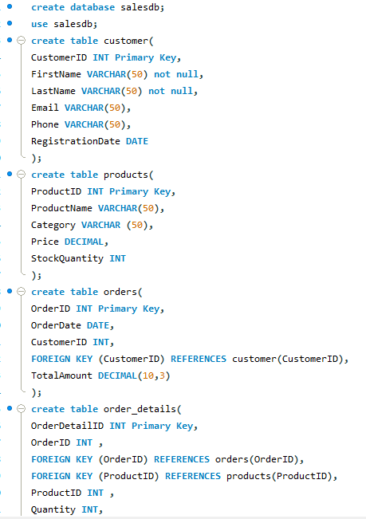

2. Insert Data

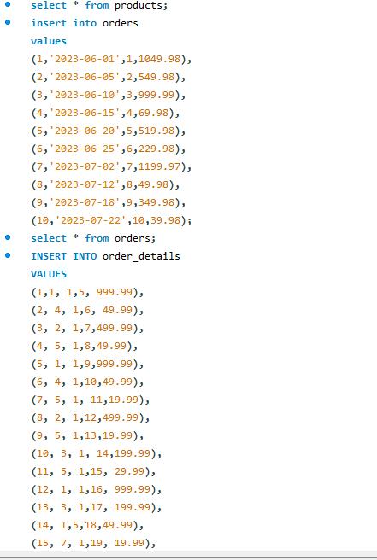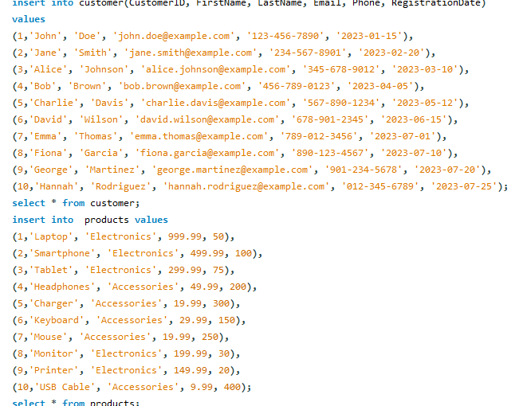

3. Retrieve all customers who registered in 2023.

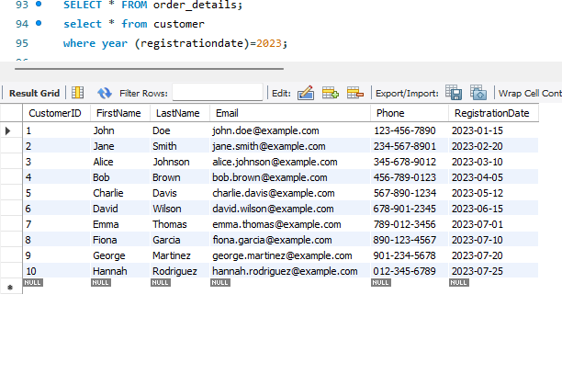

4. List all products in the 'Electronics' category.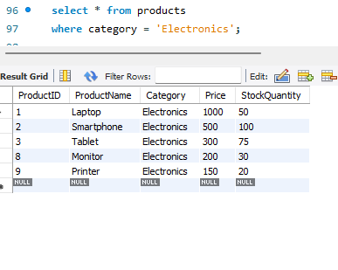

5. Find the total number of orders placed by each customer.

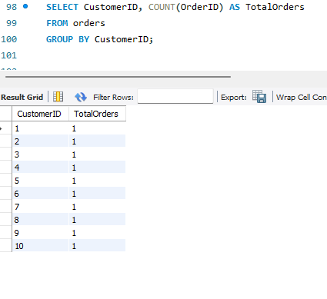

6. Calculate the total sales amount for each product.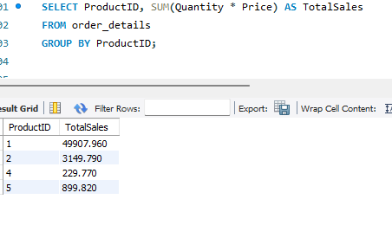

7. Retrieve the details of all orders, including the customer name and total amount.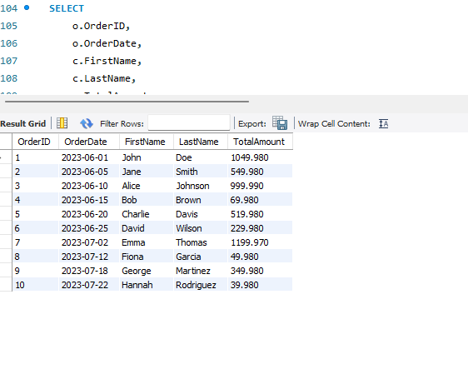

8. List all products that have been ordered along with the quantity ordered for each. 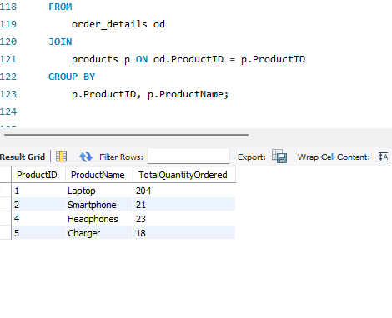

9. Find the order details for orders placed by 'John Doe'. 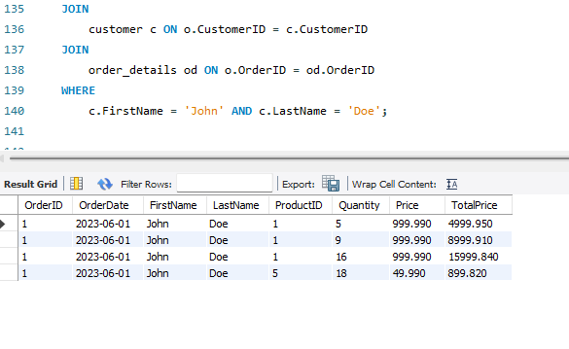

10. Find customers who have placed an order totaling more than $500. 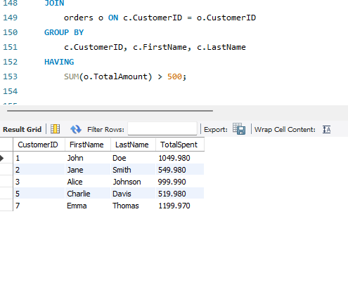

11. List the products that have never been ordered.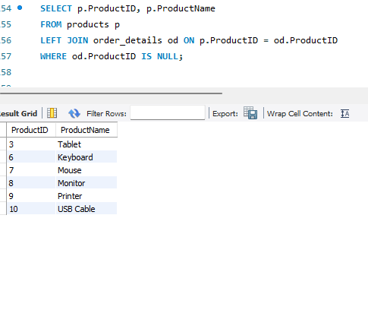

12. Retrieve the order history for a specific customer, including order date, product names, and quantities. (Assume customer ID is 2) 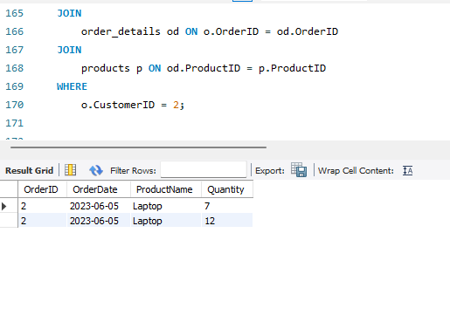

13. Calculate the average order value for each customer.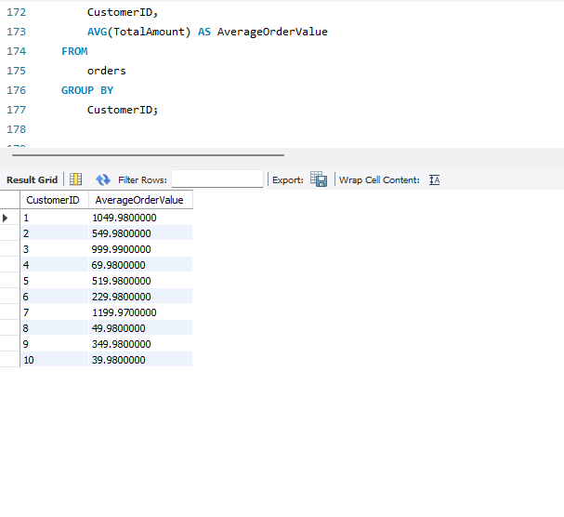

14. Find the most popular product category based on the number of orders.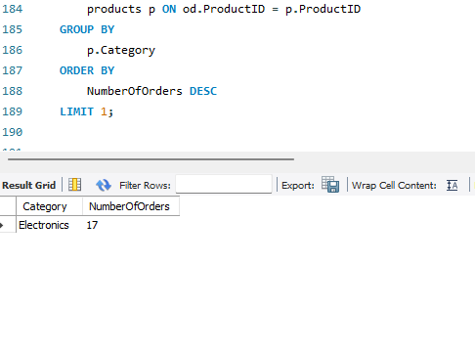

15. List all customers who have ordered more than one product in a single order.